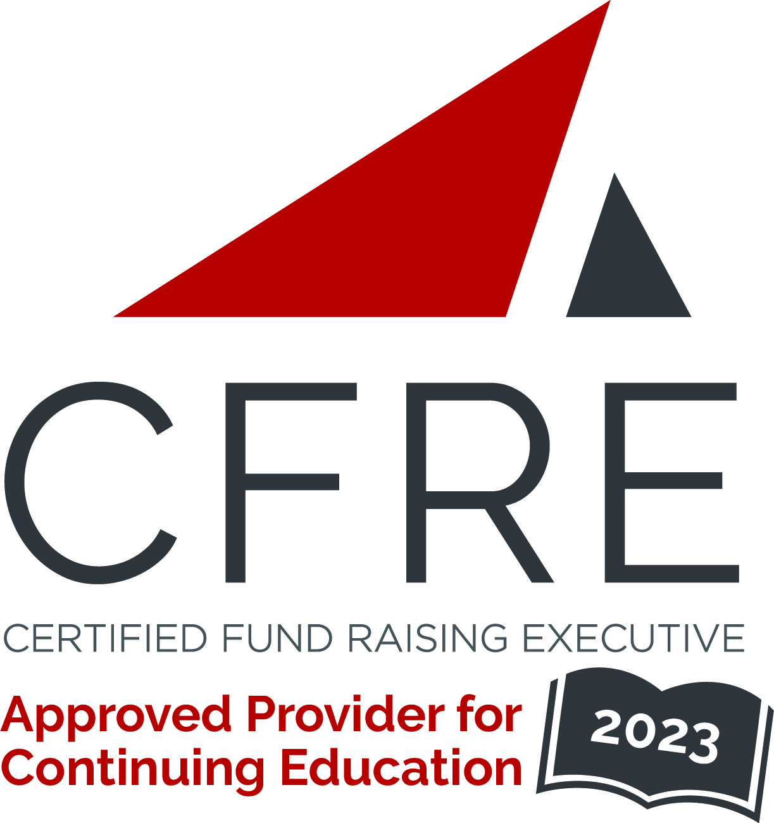
CFRE International has developed this form as a way for you to quickly track (and keep in your files!) the continuing education sessions you have attended. Simply check the boxes next to the sessions you attended. At the end of the conference, add up the total number of hours. Keep this sheet and you will be ready to complete your application form. All of the session slots listed are eligible for continuing education points on your CFRE application for initial certification and/or recertification. Sessions not listed here are not eligible for points.

CONTINUING EDUCATION POINTS TRACKER

Activity Organizer: - Nonprofit Leadership Center
Title of Activity: - Nonprofit Leadership Conference: Together We Will
Names of Presenter(s): - Various
Dates and Location: - 19-20 October, 2023 – Virtual Live

Date: 19 October, 2023
Session 1: 9:30am – 10:30am (1 pt)
- Manage Your Energy to Lead with Impact and Resilience

Date: 19 October, 2023
Session 2: 11:50am – 12:55pm (1 pt)
- Shola Richards Keynote Presentation: The Courage to go Together: Three Questions to Change How You Work, Live, and Lead

Date: 20 October, 2023
Session 3: 9:00am – 10:15am (1.25 pts)
- Leading from Any Seat to Meet Tomorrow’s Challenges
- Understanding Your Changing Workforce: How to Increase Employee Engagement Across Generations
- Make Your Workplace a Community of Belonging
- Panel: Driving Social Impact; Engaging Nonprofit Funders for Lasting Change

Date: 20 October, 2023
Session 4: 10:30am – 11:45am (1.25 pts)
- If Onboarding is So Critical, Why Don’t We Do it Well?
- How to Involve the Community in Identifying and Solving its Own Problems
- Aligning Personal Brand & Organizational Brand for Social Impact
- 10:30 AM - 11:30 AM EDT (1 hour)
10 Trends Fueling Thriving Nonprofits

Total number of points attained: _______

